Chapter 9 Homework Problems

Problem 9.1

A 50kg box is being pulled across a surface by a 200 N force in the direction shown below. If the static and kinetic coefficient of friction is assumed to be 0.3, what is the rate of acceleration of the box? Assuming the box starts at rest how far will the box move in a three second period?

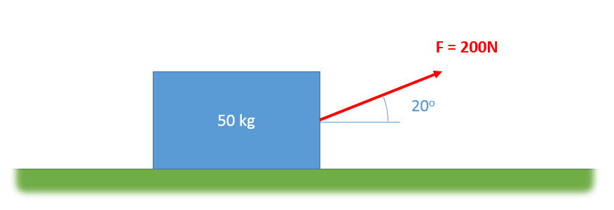

(Solution: a = 1.23 m/s2, Δx = 5.52 m)

Problem 9.2

A small 5 kg rocket is being launched vertically. The thrust force is described by the function F(t) = -5t2 + 30t + 500. Assume negligible air resistance, but do not forget the gravity force on the rocket.

* What is the time required for the rocket to first reach a speed of 500 m/s?
* What is the maximum height achieved by the rocket before it would fall back to earth?

(Solution: t = 5.166 s, ymax = 12,977.6 m)

Problem 9.3

A three-kilogram cannonball is shot out of a cannon with an initial velocity of 300 m/s at a 25o angle. A headwind exerts a constant 5 N horizontal force. How far will the cannonball travel before horizontally hitting the ground?

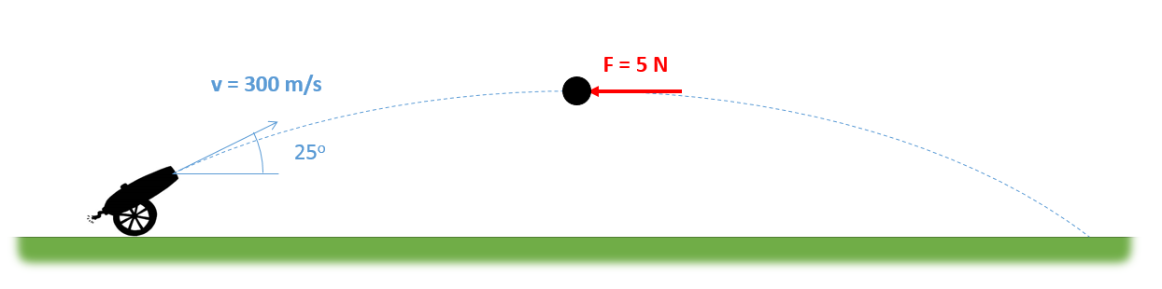

(Solution: d = 6470 m)

Problem 9.4

A steel slide is being used in a factory to move boxes down two meters from one conveyor belt to another. The kinetic coefficient of friction between the steel and the box is .4. If the box starts with a velocity of 0.7 m/s and we wish the box to have a final velocity of 0.3 m/s, what angle should the slide be at and how long should the slide be?

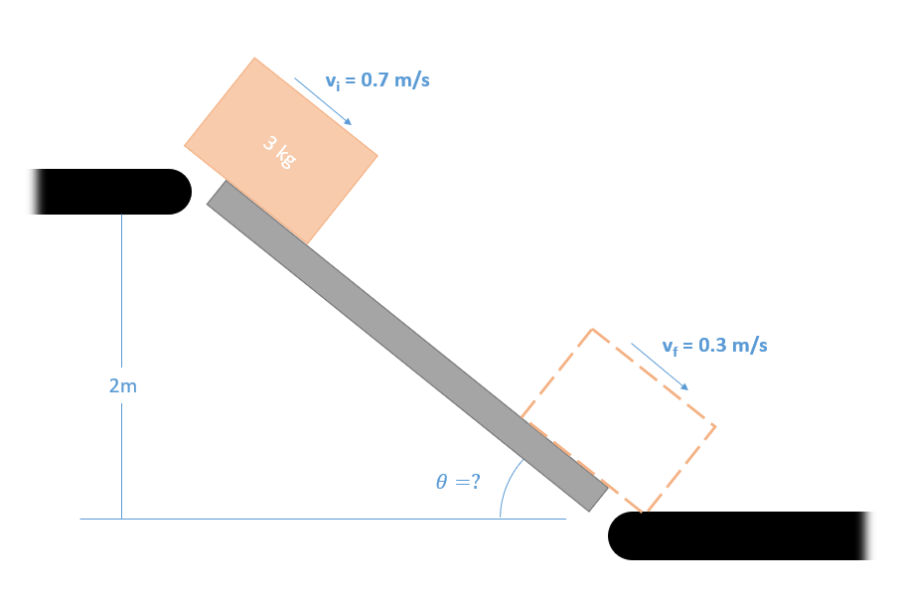

(Solution: θ = 21.6o L = 5.43 m)

Problem 9.5

A 1 kg block sits on a rotating table as shown below. If the static coefficient of friction is assumed to be .4, what is the maximum angular velocity ($\dot{θ}$) that can be achieved before the block begins to slip?

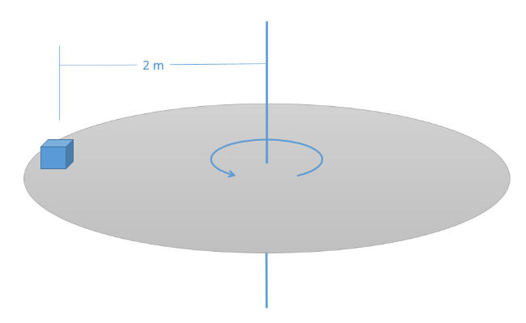

(Solution: $\dot{θ}=1.4\frac{rad}{s}$)

Problem 9.6

A 5 kg instrument is held via a cable to a space station. The instrument and space station are both rotating at a rate of .5 rad/s when the space station begins retracting the cable at a constant rate of .25 m/s.

1. What is the tension in the cable at this instant?
2. What will the angular acceleration of the cable be ($\ddot{θ}$)?

(Hint: there are no forces in the theta direction)

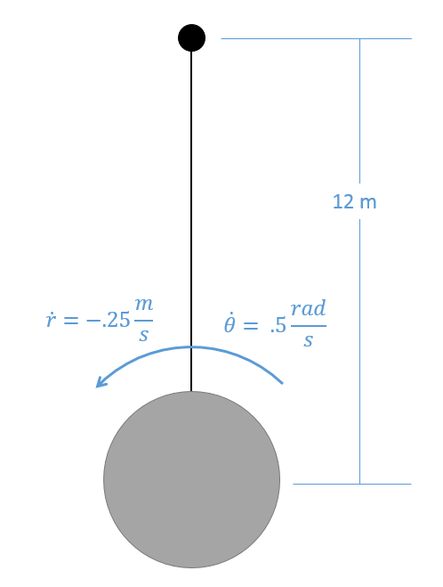

(Solution: T = 15 N, $\ddot{θ}=.0208\frac{rad}{s^{2}}$)